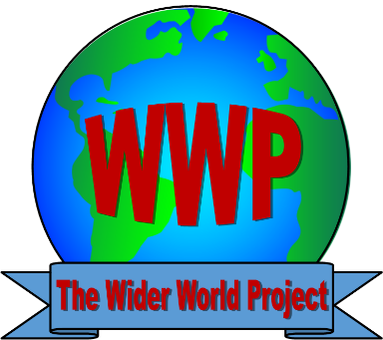
Wider World Project
Equal Opportunities Policy

Policy Statement

Discrimination is when a person is prevented from taking part in something based on a particular characteristic they have.
Harassment is when someone behaves in a way which makes someone else feel distressed, humiliated or threatened.
The Wider World Project is committed to treating all people equally and with respect irrespective of their age, disability, gender reassignment, marriage or civil partnership, pregnancy or maternity, race, religion or belief, sex, or sexual orientation”.

Aims
The Wider World Project is open to all young people age 16-35. We aim to ensure our clubs have an atmosphere of friendship, respect and care for each other. In particular, we aim to treat every member of the project and visitors and guests equally.

Accessibility
Our Clubs and activies are held in venues that are accessible to wheelchair users and people with mobility difficulties. Our main site at Belmont Community Centre has a PA system and a hearing loop.
When we organise outings for our members we ensure that there is sufficient support to meet everyones individual needs so that they can engage in all of the activities.
We are committed to ensuring that our members are able to attend our activities, so we will reassess our access requirements and support to meet the needs of new members.

Diversity
Our Project belongs to all of its members. We aim to organise a range of activities and events to suit the interests and meet the needs of a wide variety of people.
The Project is open to new ideas, and will prioritise opportunities for members to share their cultural heritage with one another.

Inclusion and respect
Every member of The Wider World Project should be made to feel equally welcome and included at all of the projects clubs, activities, offsite visits, meetings and events.
Sexist, racist, homophobic, transphobic or otherwise offensive and inflammatory remarks and behaviour are not acceptable. These constitute harassment, and have no place in the Project.

